**The**

**BioLayne**

**Foundation**

**Investing in the next generation**

# A Philanthropic initiative

|  |
| --- |
| have a direct Impact  **100 %** of your donation will go directly to scholarships and grants  **100%** of your donation is tax deductible  Sponsorship Levels:  Bronze - $100  Silver - $500  Gold - $1000  Platinum - $5,000  Olympia – $10,000  Partner sponsor over $15,000  Be a part of a first for these sports. To donate go to:  hiuh |
| https://tcfapp.org/donation  **Fund Name:**  **The BioLayne Foundation Fund** |
|  |

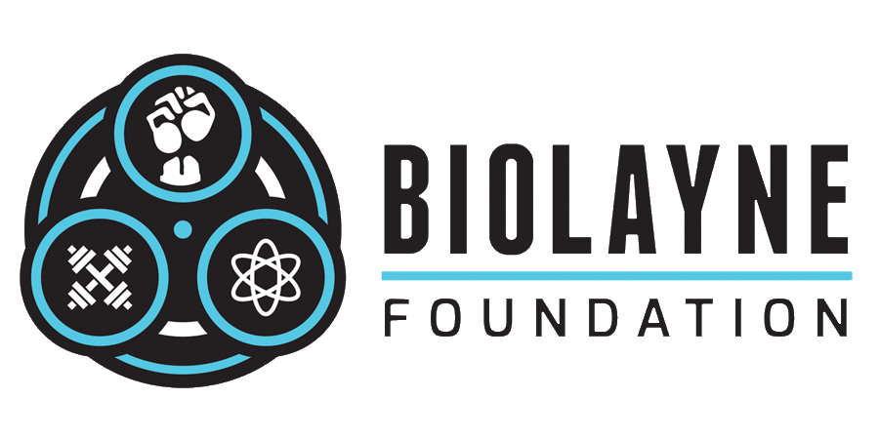

The goal of this initiative is to improve the strength sports, fitness, bodybuilding, powerlifting, etc. by providing financial assistance to the next generation of sports scientists through scholarships and grants.

## **The BioLayne Foundation Fund**

A donor advised fund has been created under the governance of The Columbus Foundation. The BioLayne Foundation Fund is able to accept tax deductible donations and then award grants to any nonprofit 501(c)(3) public charity in the United States. Almost all colleges and universities (both public and private) are registered public charities.

“The future depends on what we do in the present.” – Mahatma Gandhi

# Mission Statement

The BioLayne Foundation is a philanthropic initiative established to award financial assistance to charities supporting applicants who are pursuing advanced degrees in the areas of sports training, nutrition, metabolic health or medicine, and intend to utilize their education to advance the science of bodybuilding, powerlifting and strength training.

# Scholarships and Grants

Each year the advisory board to The BioLayne Foundation will accept and review applications for grants presented to be board for consideration. Award determination will be made by the board for Masters and Ph.D level research and study of strength sports. Funds may be used for tuition assistance, graduate student support fees, professional travel, research and lab equipment. Further criteria for consideration and applications can be found on the BioLayne web site: www.biolayne.com

# Don’t miss this opportunity to make a difference

We believe in the next generation of scientist and their ability to have an impact on the health and success of strength sport atheletes. We are asking you to please join us in our effort to make a difference.